Pulmonary Atresia/Intact Ventricular Septum and Cor Triatriatum Sinistrum
Name
Institution affiliation
Course name
Instructor
Date

Pulmonary Atresia/Intact Ventricular Septum and Cor Triatriatum Sinistrum
Pulmonary atresia/intact ventricular septum
A) Reasonable description of anatomy
Pulmonary atresia with an intact ventricular septum (PA/IVS) is a rare cardiac condition accounting for less than 1 percent of the total heart defects. The condition is characterized by long section muscular atresia of the right ventricular outflow tract (RVOT) after the lack of communication at the ventricles (Chikkabyrappa, Loomba, & Tretter, 2018). The pulmonary valve which allows blood to flow from the heart to the lungs does not form properly. The condition ranges from simple membranous pulmonary atresia (PA) with the right ventricle in its normal state to hypoplastic right ventricle having abnormal links existing between coronary arteries and the right ventricle (Gorla and Singh, 2020). An insult in the sensitive stages as an embryo develops is thought to cause this rare heart condition. However, a clear and precise condition leading to PA/IVS is still unclear.
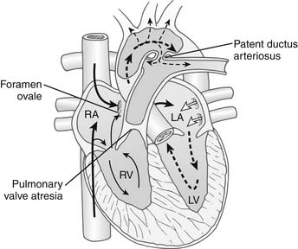

B) Reasonable description of pathophysiology
The most predominant signs and symptoms of the PA/IVS condition is include desaturation and cyanosis. The condition was first described in 1783 by Hunter and later in 1869 by Peacock. There is the presence of Pulmonary venous obstruction signs and pulmonary hypertension. Additionally, a right ventricular lift and pulmonary second sound accentuation are recurrent. There might be some early diastolic murmur of pulmonary deficiency and the presence of rales in the lung bases. Soft continuous murmur is likely to be identified due to the flow across the membrane, which can be heard with an atrial septal defect and left-to-right shunt. Low cardiac output is established as diminished peripheral pulses, tachypnea, and pallor. Children with this condition are typically small and suffer from poor weight gain. Neonates with this disease become symptomatic since the patent ductus arteriosus is closed, and the neonates' pulmonary circulation depends on it. The condition reduces the cardiac output because of the compulsory right to left pushing at the atrial septum level (CDC, 2020). The condition can be diagnosed during pregnancy or soon after the child’s birth. During birth, screening tests also referred to as prenatal test is conducted. The test helps check birth defects and any other possible conditions (Chikkabyrappa, Loomba, & Tretter, 2018). PA/IVS can be detected during an ultrasound, after which the healthcare provider can request a fetal echocardiogram for diagnosis confirmation purposes. After birth, PA/IVS shows various symptoms like bluish-looking skin color known as cyanosis, difficulty breathing, extreme sleepiness, and poor feeding (CDC, 2020). A doctor can use a stethoscope to check the heart murmur, echocardiogram, electrocardiogram (ECG), or cardiac catheterization.
C) Description of surgical correction
The heart surgery for a child with PA/IVS follows a series of heart operations. These include shunting, Glenn procedure, and Fontan procedure. Shunting involves developing a shunt right from the main blood vessel that leads out of the heart to the pulmonary arteries (Gorla and Singh, 2020). It ensures sufficient blood flow to the lungs. Glenn's procedure involves connecting one of the large veins that take blood from the heart to the pulmonary artery. The heart's right side continues to receive blood through another large vein, and the heart pushes the blood through the surgically repaired pulmonary valve. The procedure helps the right ventricle grow larger (Mayo Clinic, 2019). Fontan procedure is helpful when the right ventricle is too small to be useful. The procedure creates a pathway for the blood getting to the heart to flow directly into the pulmonary artery.
D) Necessary extracorporeal circuitry and perfusion techniques
During the surgery, cardiopulmonary bypass (CPB) is applied. The cardiologists drain the blood by gravity into a venous reservoir that is a heart-lung machine. The draining of the blood is through a single cannula at the right atrium. The medics can place specialized cannulas into the lower IVC, applying the femoral approach (Mayo Clinic, 2019). The blood can be pushed from the reservoir through a hollow fiber oxygenator after a proper gas exchange in the systemic arterial system via a cannula in the distal ascending aorta or the axillary artery (Chikkabyrappa, Loomba, & Tretter, 2018). The extracorporeal perfusion system helps to provide total or partial respiratory and circulatory support.

Cor Triatriatum sinistrum
A) Reasonable description of anatomy
Cor triatriatum sinister is normally a rare congenital abnormality that is diagnosed in childhood stages. Reports show that few cases remain asymptomatic only to be diagnosed in adulthood. They comprised of a heart with three atria that is a congenital anomaly (Rudienė, 2019). In such a case, the left atrium is divided into two sections by a membrane, tissue, or fibromuscular band. The superior section of the atrium receives the vein blood. On the other hand, the inferior section is attached to the atrioventricular valve and consists of an atrial appendage that bears the fossa ovalis.
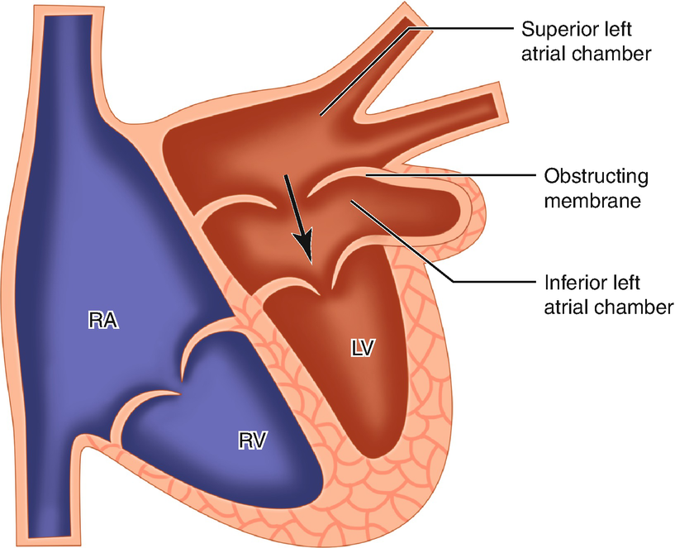
B) Reasonable description of pathophysiology
The first Cor triatriatum sinister cases were reported in 1868. The commonest finding for this condition is examining central (perioral and periorbital) cyanosis followed by ductal closure. There is pronounced apical left ventricular impulse. There is the presence of single first and second heart sounds. At the left lower sternal border, a pansystolic murmur is heard and is remains constant with tricuspid regurgitation. A severe murmur of tricuspid regurgitation is likely to result in a thrill and diastolic rumble. Additionally, if there is a patent ductus arteriosus, a medic can hear the systolic ejection murmur left second and sometimes third anatomic space. The condition classification is based on the size and number of openings of the accessory membrane into the left atrium. Small openings symptoms include wheezing, coughing, and an abnormal buildup of fluids in an infant’s lungs. In older people, the symptoms of this condition may include pain and discomfort when breathing(dyspnea), abnormal swellings of certain body areas (generalized edema), abnormally fast heartbeat(tachycardia), and an excessive buildup of fluids in a patient's lungs (pulmonary congestion) (Jha & Makhija, 2017). To diagnose Cor triatriatum sinister, medics may use magnetic resonance imaging (MRI) and echocardiography (EC). Cardiac catheterization is another procedure that uses a long fine tube that a medic inserts into the large vein (Schusterova, Czerny, Jurko & Minarik, 2015). Then, it is directed into the heart. Angiography is another effective diagnostic procedure that physician views the heart’s condition with an enhanced x-ray.
C) Description of surgical correction
The surgical management of Cor triatriatum sinister uses the median sternotomy and standard cardiopulmonary bypass, which involves bicaval cannulation, cardioplegic arrest, and mild hypothermia. There two approaches to surgically managing the condition, but it depends on the morphology of its defect or the presence of other cardiac issues (Rudienė, 2019). The left atrial approach is chosen for older children and adults. This is because they have a sufficient size of the atrium that allows adequate exposure. The approach involves preparing the inter-atrial groove, opening the atrium superiorly to the right pulmonary veins. The trans-septal approach, also known as right atrial, is effective for infants and children (Jha & Makhija, 2017). The approach involves opening the right atrium, incising the interatrial septum along the oval fossa's upper border heading straight to the right upper pulmonary vein.
D) Necessary extracorporeal circuitry and perfusion techniques
When undertaking the surgery, the cardiologist applies the cardiopulmonary bypass technique. There is the blood draining by use of gravity effect into a venous reservoir that is a heart-lung machine. The blood draining is through a single cannula at the right atrium (Jha & Makhija, 2017). The cardiologists use the specialized cannulas into the lower IVC applying the femoral approach after which the blood can be taken from the reservoir through a hollow fiber oxygenator after a proper gas exchange in the systemic arterial system via a cannula in the distal ascending aorta or the axillary artery (Schusterova, Czerny, Jurko & Minarik, 2015). The extracorporeal perfusion system helps to provide total or partial respiratory and circulatory support.

MAPCA-Major Aortopulmonary Collateral Arteries
- Reasonable Description of Anatomy
MAPCA-major aortopulmonary collateral arteries are unusual vessels that generally grow from the aorta and supply oxygenated blood to the pulmonary parenchyma. They are linked with a congenital heart condition. Lack of evidence of any structural heart condition makes it difficult to identify it. MAPCA-major aortopulmonary collateral arteries are rare in isolation (Kunwar, Paddalwar & Ghogare, 2017). According to previously published reports, cases of symptomatic infants having large isolated MAPCA are likely to show congestive heart failure or some recurrent respiratory tract infections.
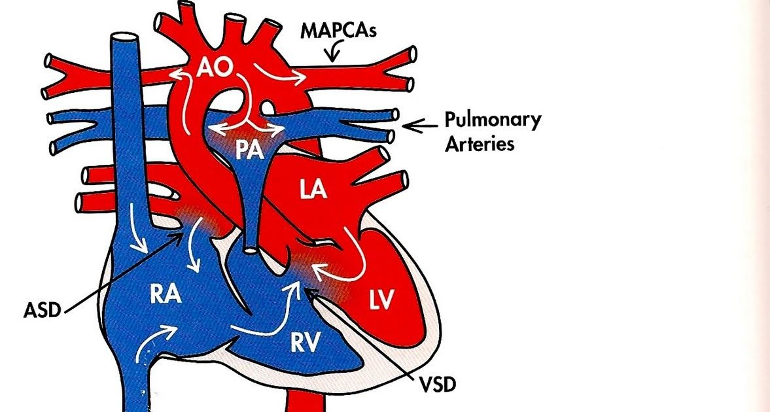

- Reasonable Description of Pathophysiology
MAPCA-major aortopulmonary collateral arteries are commonly linked with pulmonary atresia with ventricular septal defect (PA/VSD). Nevertheless, some patients with MAPCAs do not necessarily have PA/VSD but might have other anatomic diagnoses. For new infants, a clinical presentation for aortopulmonary collaterals constituting the only source of pulmonary blood flow is likely to be different from cyanosis with blood flow (Patrick et al. 2017) In common cases, pulmonary blood flow will adequately increase, resulting in symptoms of pulmonary overcirculation like excessive sweating and rapid breathing. MAPCA-major aortopulmonary collateral arteries diagnosis may produce hypoxemia which can be severe for a newborn infant survival since the ductus arteriosus may close.
- Description of Surgical Correction
Neonates who have adequate-sized confluent pulmonary arteries are likely to undergo definitive surgical repair. A palliative procedure with a systemic-to-pulmonary artery shunt can help promote central pulmonary artery growth after the surgical operation is complete. The surgery helps to; incorporate multiple pulmonary artery sections into the pulmonary artery confluence and introduce a conduit connected to the pulmonary artery confluence from the right ventricle (Kunwar, Paddalwar & Ghogare, 2017).
D) Necessary Extracorporeal Circuitry and Perfusion Techniques
While a patient is to undergo a surgical operation, the right ventricular outflow tract transcatheter perforation is required, followed by balloon dilation. The blood is drained into a reservoir through a fiber oxygenator (Babliak et al. 2017). The extracorporeal perfusion system ensures that there is constant circulation support throughout the surgery.

References
Gorla S and Singh A, (2020). Pulmonary Atresia With Intact Ventricular Septum. Retrieved March 1, 2021, https://www.ncbi.nlm.nih.gov/books/NBK546666/
Hamdan R and Nassar P (2017). Cor Triatriatum Sinistrum: Classification and Imaging Modalities. Retrieved March 1, 2021 from https://www.ncbi.nlm.nih.gov/pmc/articles/PMC3286827/
Mayo Clinic, (2019). Pulmonary atresia with intact ventricular septum. Retrieved March 1, 2021, from https://www.mayoclinic.org/diseases-conditions/pulmonary-atresia-intact-ventricular-septum/cdc-20396714
Rudienė, V., Hjortshøj, C. M., Glaveckaitė, S., Zakarkaitė, D., Petrulionienė, Ž., Gumbienė, L., ... & Søndergaard, L. (2019). Cor triatriatum sinistrum diagnosed in the adulthood: a systematic review. Heart, 105(15), 1197-1202.
Schusterova, I., Czerny, M., Jurko Jr, A., & Minarik, M. (2015). A very rare case of late diagnosis of cor triatriatum sinistrum. J Geriatr Cardiol, 12(2), 185-6.
Kunwar B, Paddalwar S & Ghogare M (2017). Large Isolated Major Aortopulmonary Collateral Artery Causing Severe Pulmonary Hypertension in an Infant: A Rare and Challenging Diagnosis. Retrieved March 3, 2021, from https://www.ncbi.nlm.nih.gov/pmc/articles/PMC5535423/
Babliak, O. D., Mykychak, Y. B., Motrechko, O. O., & Yemets, I. M. (2017). Surgical treatment of pulmonary atresia with major aortopulmonary collateral arteries in 83 consecutive patients. European Journal of Cardio-Thoracic Surgery, 52(1), 96-104.
Patrick, W. L., Mainwaring, R. D., Reinhartz, O., Punn, R., Tacy, T., & Hanley, F. L. (2017). Major aortopulmonary collateral arteries with anatomy other than pulmonary atresia/ventricular septal defect. The Annals of thoracic surgery, 104(3), 907-916.
Jha, A. K., & Makhija, N. (2017, June). Cor triatriatum: a review. In Seminars in cardiothoracic and vascular anesthesia (Vol. 21, No. 2, pp. 178-185). Sage CA: Los Angeles, CA: SAGE Publications.
Chikkabyrappa, S. M., Loomba, R. S., & Tretter, J. T. (2018, September). Pulmonary atresia with an intact ventricular septum: preoperative physiology, imaging, and management. In Seminars in cardiothoracic and vascular anesthesia (Vol. 22, No. 3, pp. 245-255). Sage CA: Los Angeles, CA: SAGE Publications.
CDC, (2020). Facts about Pulmonary Atresia. Retrieved March 1, 2021, from https://www.cdc.gov/ncbddd/heartdefects/pulmonaryatresia.html

